Autoscaling Configurations with ORM stack

Contents

1. Introduction 3
2. Workflow diagram to deploy the stack 3
3. Create stack for Autoscaling configuration 4
4. Plan the Job 9
5. Apply the Job 11
6. Verify in the Console 12
7. Destroy the stack 23

Introduction

Autoscaling let automatically adjust the number or the lifecycle state of compute instances in an instance pool. This helps provide consistent performance for your end users during periods of high demand, and helps reduce your costs during periods of low demand.
User can apply the following types of autoscaling to an instance pool:
Schedule-based autoscaling: Autoscaling events take place at the specific times that you schedule.
Metric-based autoscaling: An autoscaling action is triggered when a performance metric meets or exceeds a threshold.
Autoscaling is supported for virtual machine (VM) and bare metal instance pools that use standard, dense I/O, and GPU shapes.
Prerequisites:
- Instance Pool OCID

Workflow diagram to deploy the stack

Below diagram shows how the Terraform Artifact are applied in the OCI. While creating a ORM stack, using terraform deliverables Init, Plan and Apply is the flow to provision the resource in the OCI. We can have the deliverables in any of below.

- GitLab/GitHub Repo
- Bitbucket
- Can be in folder/.zip in the local disk
- Object Storage Bucket
- Can be in compartment
- Oracle provided Template


Create stack for Autoscaling configuration

Go to OCI Console Developer Services Resource Manager Stacks select the compartment Create Stack

My Configuration Folder Browse Select the “autoscaling_configuration” folder that contains the terraform Upload
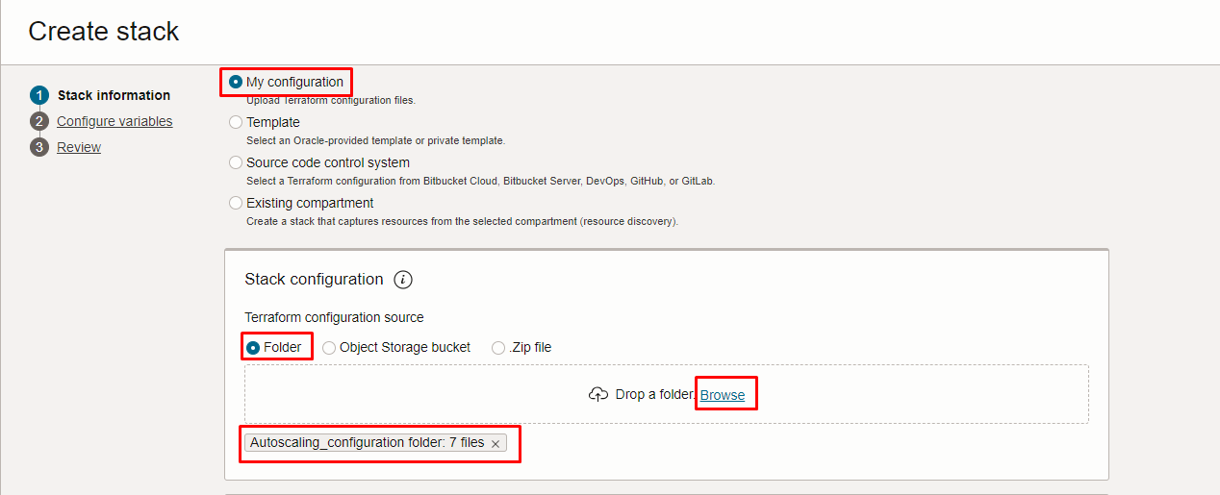
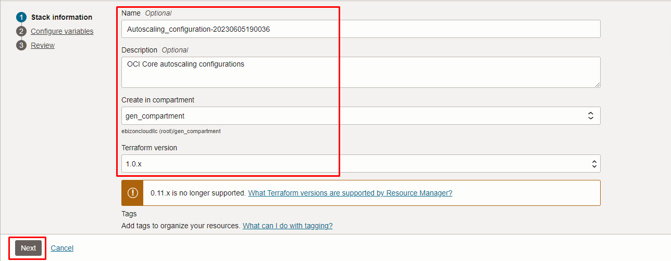

Click “NEXT”
Select the parameters as per the below screen,
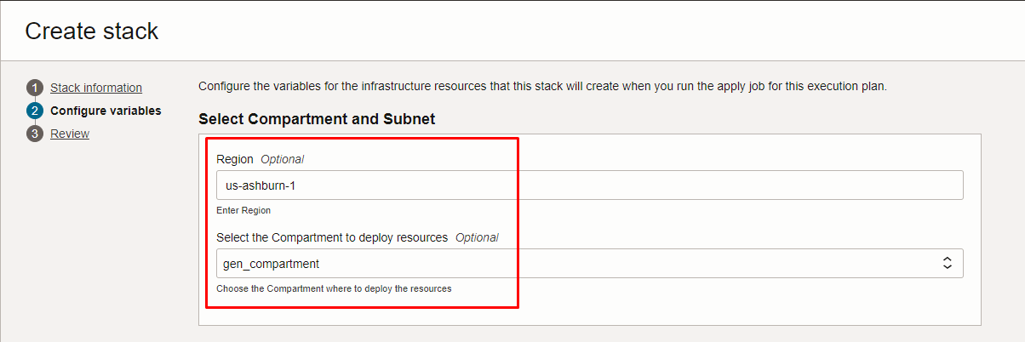

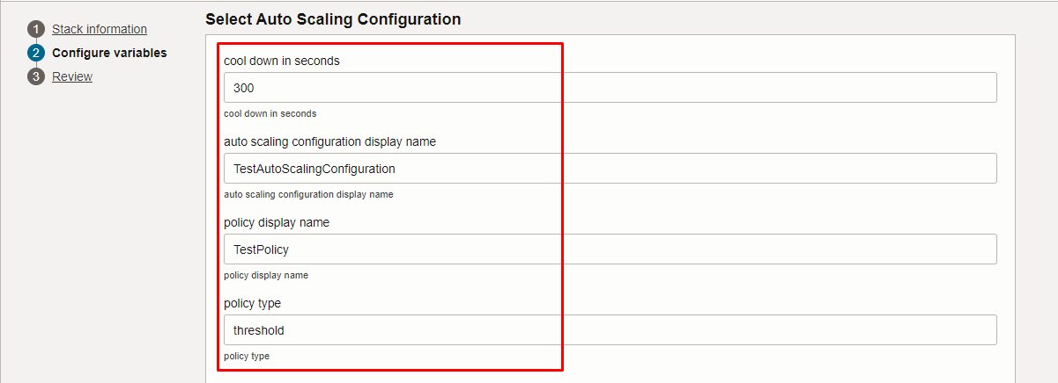

Click “NEXT” Click “CREATE”

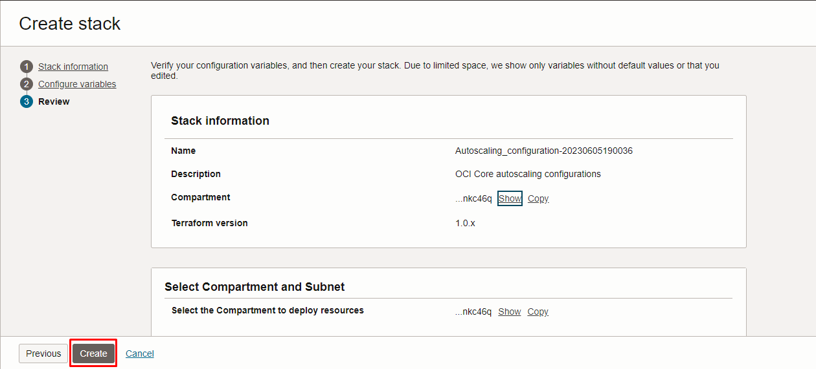

Plan the Job

Click the “Plan”
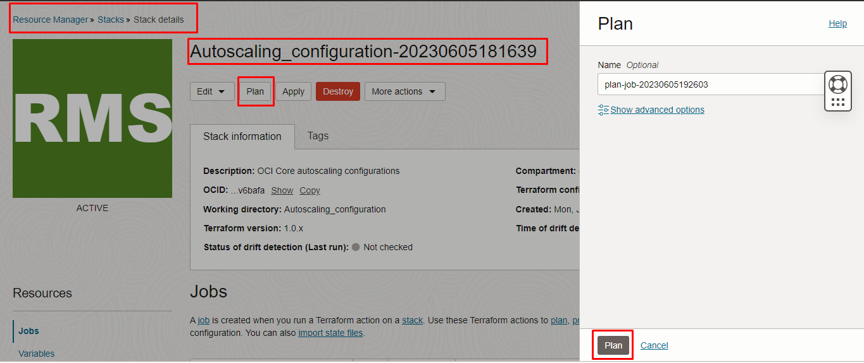
Verify the Plan is successful.

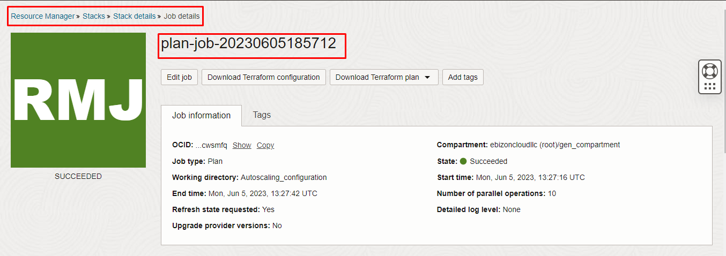

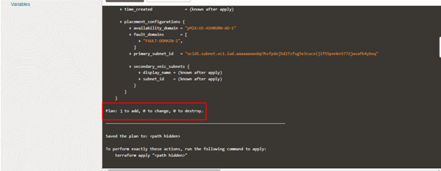

- Apply the Job
Once the “plan” is success, now click “Apply”

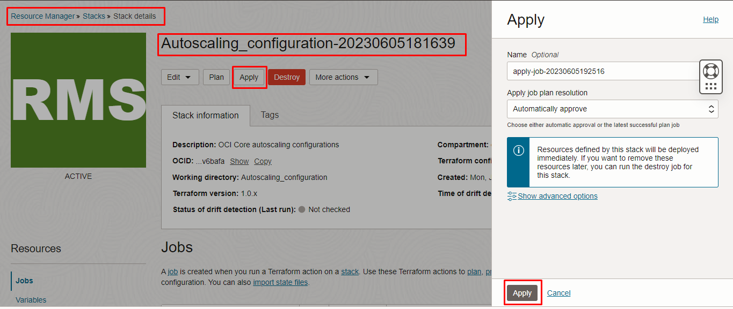

Verify the Apply is successful.

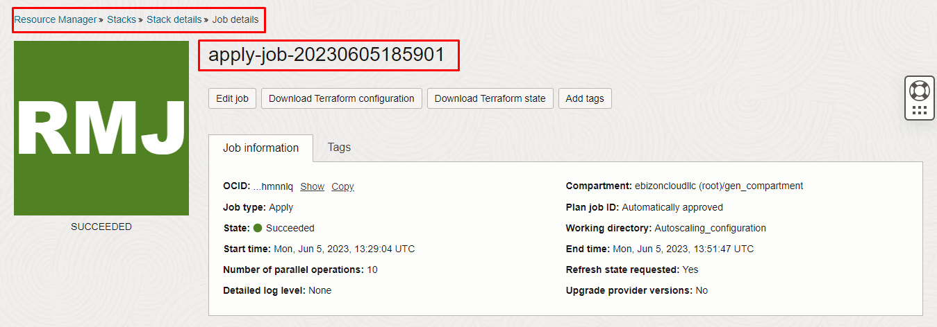

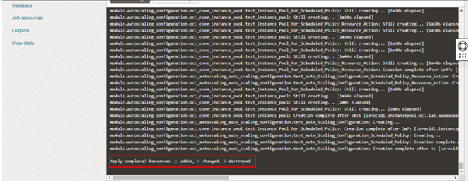

Verify in the Console

Go to OCI Console Compute Autoscaling Configuration

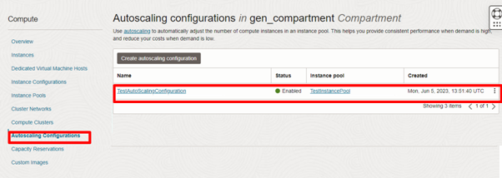
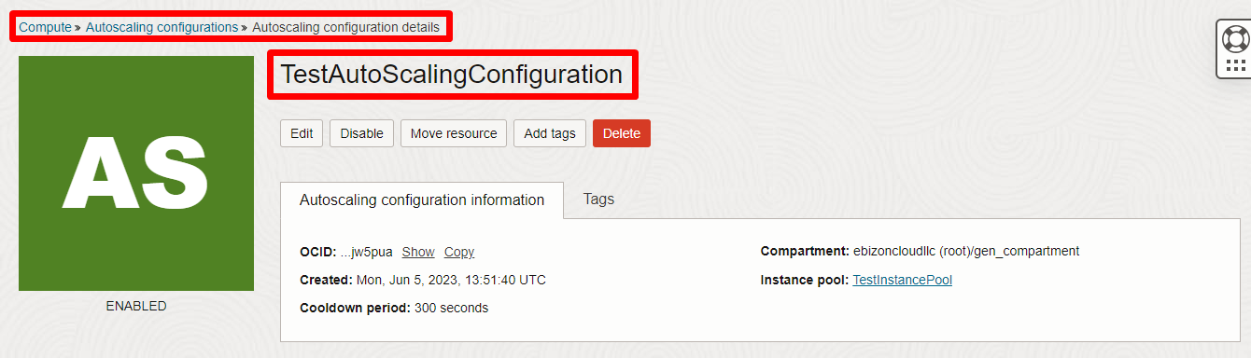

Destroy the stack
Create a destroy job in Resource Manager to release resources associated with a stack and clean up the tenancy. Once destroyed data cannot be recovered from resources.

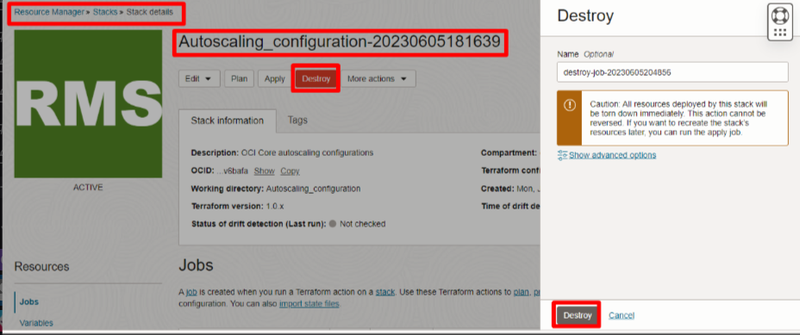

###END###

